‘Ride the Change’ COP26 Bike Ride
About 70 cyclists who are cycling from London to Glasgow for COP26 will be staying in Penrith on the night of Thursday October 28th. There will be an open meeting at Christ Church, Penrith, on Thursday evening at 8pm.
You are invited to come along to meet the cyclists and hear about their journey and their hopes for the conference.
Tea/coffee and biscuits will be provided.
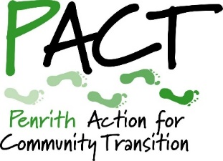
Please wear a mask if possible and be prepared to give your contact details for Track and Trace.
This meeting is being organised by
PACT, supported by
Churches Together in Penrith
The cyclists will be setting off from the Quaker Meeting House, Penrith, at about 9am on Friday morning. You are welcome to come and wave them off as they head off to Dumfries on the next leg of their journey.

