PACT meeting number 2021-6 – Thursday 1st July 2021
7.30pm at White Gables, Wordsworth Street and via Zoom
Present:
In person: John Bodger (Chair), Christine Sutherland (Secretary), Frances Bell,
Geoff Rockliffe-King, Liz Jablonski, Lucy Teather, Richard Waller,
Rosie Bradshaw
Via Zoom: Malcolm Carruthers, Ali Ross, Chris Cant, Jaki Bell, Joan Robinson,
Nigel Jenkins
1 Apologies
Peter Simpson, Philip Sturgess (Treasurer), Virginia Taylor
2 Declarations of financial interest
None declared.
3 Minutes of last meeting and matters arising
The minutes of last meeting were accepted. Proposed by John, seconded by Rich.
Matters arising:
ZCC Youth Work: Rosie is currently doing some mapping work. This will be finished by the end of July.
Penrith Town Hub: John has written to Charlie Shepherd and Rosie has spoken to Kerry Morgan, PTC’s new sustainability officer.
Projects for students: If anyone can think of suitable projects for Rich’s students please contact him.
PACT Admin
4 Finance update
Report from Philip - the only payment since the last meeting was Rosie’s fee of £492.28. Geoff reported that today the latest quarterly instalment from ZCC had arrived, with an extra £25 as a thanks to PACT for managing Rosie’s other work for ZCC. John has invoices for litter-pickers and hi-vis jackets to claim for.
5 Volunteer hours
Rosie will ask us quarterly for an estimate of our volunteer hours. This is for everyone who volunteers on behalf of PACT, not just work on specific ZCC projects. Rich will provide a simple form we could use.
6 Town Centre stalls
Starting this Saturday, 3rd July, then on the 4th Saturday of each month. We have booked the bandstand in the Cornmarket, this is now managed by PTC and free of charge to community groups. Christine had prepared a risk assessment based on the one used for Carlisle’s stall. Lead person this time is John B.
Themes this time: refill scheme, plastics, Freegle info, some Grow your own.
Possible main focus for future stalls: GYO (end of July), coal mine (August), extreme weather (Sept), COP26 (Oct), energy saving (Nov)
Each time: COP26 (leaflets coming from Carlisle), biodiversity
(Coal Mine: judicial review starts 7th Sept. We need to talk to the public, flag up the alternatives eg green jobs and the disadvantages for the area in terms of pollution etc.)

7 Repair cafés
Hoping to go ahead on July 10th but negotiating different sets of rules. Max 10 people inside the Old Fire Station, will also have gazebos outside. Plan to continue on the second Saturday of each month, hopefully restrictions will be relaxed. Jaki and Chris will liaise about promoting these in the PACT newsletter and social media.
8 Bounce Forward
The trial was successful, we need to start planning soon for the follow-up event. Suggest this is held after COP26. We need to consider who will be invited and whether to hold it ‘live’ or on Zoom.
9 Big Green Week – 18th to 26th September
Chris is hoping to run a Freegle Give and Take on Saturday 18th. Our stall in the bandstand will be on Sat 25th and will focus on COP and perhaps extreme weather. Rich offered a talk during the week, a primer to help people engage with the language of COP. We understand Hazel at CAfS will be running carbon literacy sessions during that week so we need to liaise with her.
10 Peat
Christine has drafted a survey form. She, Jaki and Frances will liaise about the best way of taking this forward. We can list sources of peat-free compost on our website. We need to find out who else is campaigning eg Wildlife trusts, the Co-op. Rich suggests a field excursion to Cliburn Moss. Also a contact from the Eden Rivers Trust who could give a talk about the ecological value of peat in the landscape.
11 Community Gardeners
Joan’s detailed report is attached.
Daffodil planting with UCC year 7’s and their families: We approve this as a PACT project to be delivered by the Community Gardeners. Sarah Vardy is the teacher in charge.
12 Appleby Edibles
Lucy’s report is attached.
13 Cumbria Sustainability Network
The group has had a lot of meetings recently, figuring out what it wants to be. John volunteered to be lead rep. It has been suggested that we send two reps each time, taking turns – we will arrange this by email.
14 Eden Local Plan consultation
There is a consultation on the EDC website – we are all asked to respond to this before August 9th. This is just a partial review of the local plan focussing on environmental and sustainability issues and design.
The link to the EDC local plan consultation is here: https://cumbria.citizenspace.com/eden-district-council/eden-local-plan-partial-review/consultation/intro/
And there is more information about the context and purpose of the local plan partial review here: https://cumbria.citizenspace.com/eden-district-council/eden-local-plan-partial-review/
15 Penrith & Eden Refugee Network petition
The network have written a letter to be sent to Neil Hudson. We agree to circulate the petition to members for them to sign if they wish.

16 AOB
- Penrith Town Centre Group: John suggests that this informal group could become a sub-group of PACT. We agree to discuss this next time.
- No Mow: Thanks to all involved in the No Mow project and the recent excellent Herald article.
17 Date of next meeting
Thursday 5th August, 7.30pm. In Geoff’s garden, weather permitting! Also on Zoom.

To invite:
EDC Climate Change Team (Corentin, Adrian Banford, Jasmine)
Cezary Flak (Greener every Day - www.greenereveryday.co.uk)
Kerry Morgan, PTC new sustainability officer

Need to discuss:
Membership
AGM – date + arrangements

Glossary
CAfS Cumbria Action for Sustainability
EDC Eden District Council
PTC Penrith Town Council
UCC Ullswater Community College
ZCC Zero Carbon Cumbria

Community Gardening Update
Community Gardeners have been meeting after our weekly sessions in different members gardens for coffee and cake - a real treat. Our group has become a really great supportive team like an extended family.
Bulbs at the Castle
2000 wild daffodil bulbs now ordered for September to be planted along the lower slope (road side) of the Castle. This will be an 'ice breaker' for the new yr7 and families from UCC in September over a w/end. One of the teachers and Head of Year 7 will lead on this with Community Gardeners supporting.
It is hoped to finally get permission from some top organisation/body to go ahead (we have jumped thro' several hoops so far.) If permission is not forthcoming we have made arrangements to plant the bulbs in the wooded area in St Andrews churchyard which is about to get tlc.
We intend to launch an appeal for funds £20 buys 100 bulbs, perhaps to remember someone (name to appear during first years flowering). We also have money in gardening fund given to us to support this initiative.
Cumbria in Bloom / Britain in Bloom Judging 14th and 21st July.
Various sites we look after in town will be judged as well as the town. A video is being made to send to RHS as we are representing Cumbria in Britain in Bloom.
BBC Gardening World Magazine an article about us will appear soon.
Coronation Garden I remember Peter Ward saying 'build capacity' to do this I would add talk, talk, talk and then some more.
Example.....From a run down council maintained border in our town we now have, the WI, Com Gardeners, Methodist Gardeners, Old Codgers, Penrith & District Soroptimists stepping up prepared to give sections tlc. Pic attached shows WI planting 20 ferns under the trees given to us by Anthony Leeming, Skirsgill House, who is one of our supporters.
Trees We have more and more tree saplings being offered to us.
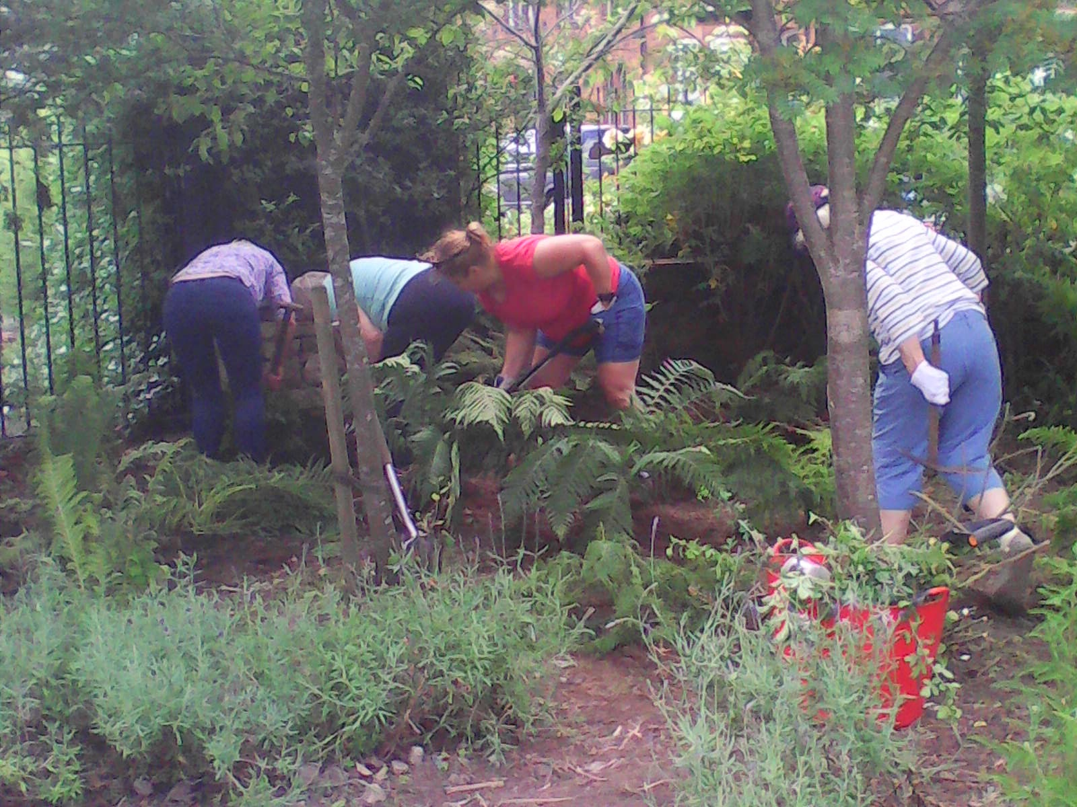
Wombling Eden an amazing facebook group of volunteers picking up litter and supporting each other through fb comments and photos.
Our thanks to PACT for support.
Joan Robinson 30/06/2021

Appleby Edibles and Lucy Update
Appleby Edibles are collecting green waste from work done by Appleby Smarter volunteers to add to the growing compost collection. AS are coming to help AE at the Heritage Centre Site Mon 12th & 19th July.
Susan Fryer, EDC in post to manage Appleby's Heritage Action Zone till March, visited Fri 9th June. We talked about her role as head gardener on Sark's 'Permaculture Garden' amongst other things. Appleby Edibles will be hosting an Introduction to Permaculture. Date tbc.
I am visiting Mark Shiperlee's 'LAND Demonstration Site' this weekend.
Mark Shipperlee - Soil Regen Summit 2021 by Soil Foodweb School, LLC
Mark Shipperlee | Permaculture Association
I volunteered with Garden Organic at Temple Sowerby after School Gardening Club and at Susan's Farm next to COGF Stall. It was good to talk with Jane Maggs about Sustainable Food Places and Food Clubs run through Fare Shares. Frankie Kennet will soon be job sharing the Cumbria Master Composters Coordinator role with Monique at CWT Gosling Syke and will, I hope, call in to the PACT Stall this Saturday.
RHS CIB Judges coming Wed July 7th . 1pm. to The Appleby Heritage Centre Site.
I will prepare a presentation to include the second site on Colby Lane that we were given last May whilst we had no site at all. Bee Keepers were coming with Hives, but have now decided that they need at least 10 around Appleby for them to make it economically viable to come and look after them here. This Garden is tended by Nikki Brabant, amougst others, A Primary School Teacher, who set up the Wombling Free Eden Litter Picking Group that now has nearly 500 Members. The Colby Lane Garden is also opposite Castle and Coasts Housing Association.
Stuart Glencross, NHS Living Well Coach, Eden Wellbeing Service came from Temple Sowerby and was happy we're here. He will publicise events if we send him information.
I am designing the space, to include replacing and replanting Hilary's 64 tree heritage apple cordon in a slightly raised bed, mulched with birch chippings, refreshed each year to suppress weeds. Hilary gave most of them away on eviction last March. Her Apple Cordon from Newton Rigg went to Lowther, where they will now be delivering Horticulture.

